Minutes of the Annual Meeting of Hanbury Parish Council – Monday 18th May 2026
Present: Cllr J Harrison; Cllr Hendon, Cllr Gregson, Cllr Tyson; Cllr Choules
Also present: C Holmes; 0 Parishioners
- Election of Chairman & Signing of the Declaration of Acceptance of office

Cllr Gregson proposed Cllr J Harrison. Seconded by Cllr Hendon. All in favour.

- Election of Vice Chairman & Signing of the Declaration of Acceptance of Office

Cllr J Harrison proposed Cllr Hendon. Seconded by Cllr Gregson. All in favour.

- Apologies for absence

Cllr Hudson; Cllr White; Cllr L Harrison

- Declarations of Interest
None

- Chair’s Welcome

The chair welcomed everyone present.

- Public Forum

None present.

- Minutes of the Meeting of the Parish Council held on 9th March 2026
All agreed to be a true record of the meeting.

Action: Clerk to convert to upload to website

- Matters arising from those minutes.

None

- Review Planning Applications.

Planning number | Premises | Planning requested | Comments by HPC | Decision
P/2025/00071 | Unit 1, Newborough Road, Needwood, DE13 9PD | Conversion and alterations to existing agricultural building to form a dwelling and retention of gravelled area | The parish council have no comments | Registered
P/2025/00676 | 3 Meadow View Close, Hanbury, Staffordshire, DE13 8FP | Erection of single storey rear extension. | The parish council have no comments. | Registered
P/2025/00695 | Saltbrook Meadow Farm, Saltbrook Lane, Coton In The Clay , DE6 5GY | Application for a Certificate of lawfulness for continued use of agricultural buildings as a Vehicle Repair shop (Class B2) and a Storage Building (Class B8) and associated land for parking, servicing and external storage | The parish council have no comments. | Registered
P/2025/01136 | Cock Inn  Hanbury Hill  Hanbury  Staffordshire  DE13 8T | Change of use of outbuilding, to hot and cold food takeaway and farm shop (sui generis), ancillary to the main establishment (amended description) | The parish council wish to support this application. | Permits
P/2025/01215 | HUNTS CROFT HANBURY HILL HANBURY DE13 8TD | Certificate of lawfulness for the continued use of building as a separate dwellinghouse (Class C3) | The parish council have no comments | Registered
P/2025/01367 | IVY COTTAGE HANBURY HILL HANBURY DE13 8TD | Erection of a single storey rear extension | The parish council have no comments | Permits
P/2026/00197 | FAULD HALL FAULD LANE FAULD DE13 9HR | Application under Section 73 to vary condition 2 (plans) attached to planning permission P/2025/00830 for the Demolition of existing rear conservatory to facilitate the erection of a single storey rear extension to the north elevation, repair and replacement of windows including addition of double glazing on selected windows, removal of modern dormer window on the south elevation and replacement with heritage rooflights and internal and external repairs to historic building fabric, to amend the window profiles, glazing bars and type of glazing | The parish council have no comments | Registered

P/2026/00198 | FAULD HALL FAULD LANE FAULD DE13 9HR | Application under Section 19 of the Planning (Listed Building/Conservation Areas) Act 1990 to vary Condition 2 of Listed Building Consent P/2025/00883 for the Demolition of the existing rear conservatory, erection of a single storey rear extension to the north elevation, repair and replacement of windows including addition of double glazing on selected windows, removal of modern dormer window on the south elevation and replacement with heritage rooflights and internal and external repairs to historic building fabric, to amend the window profiles, glazing bars and type of glazing | The parish council have no comments | Registered
P/2026/00267 | 1 WELLINGTON COURT LANCASTER PARK NEEDWOOD DE13 9PS | Installation of window to south elevation. |  | Permits
P/2026/00350 | REAR OF HANBURY GRANGE WOOD LANE HANBURY DE13 8TG | Removal of 28m of hedge row |  | Permits

- Receive Borough and County Councillors reports.

No reports received.

- To review and approve the data audit 2026

The data audit was reviewed and approved

Action: Clerk to upload to the website

- Annual Governance & Accountability Return
12a: Minute to accept in the internal auditor’s report.
The internal report was accepted by the council. The certificate of exemption was also accepted.
12b: Complete the Annual Governance Report.
The Annual Governance report was signed by the RFO & Chair
12c: Complete the Accounting Statement for 2025/2026.
The Accounting Statement was signed by the RFO & Chair
Action: Clerk to send to Mazars, add to website & noticeboard
- Clerk’s Report: to include banking changes & finance & correspondence received.
CORRESPONDENCE & ONGOING MATTERS

Still awaiting date from BB Trees in relation to work being undertaken. Parish Council to chase.

Staffs CC contacted about the changes to SID processes but no response in relation to this. It was agreed for the Parish Council to chase this and ask for timelines and to also contact County Councillor White and MP Jacob Collier.

Register of Interest forms sent out to all councillors to complete for 2026/2027

Still no response in relation to the installation of telegraph poles.

Correspondence regarding the damaged mile marker on A515. It was estimated that this would cost roughly £1700 to fix. It was noted that Staffordshire County Council is technically the owner of the marker; however, the Milestone Society does not have sufficient funds to undertake the work themselves.
It was reported that Staffordshire County Council Highways had advised that there is currently no available funding within the Highway Maintenance budget for this type of work and suggested that the Parish Council may wish to consider whether it could assist with funding or explore external funding opportunities. It was agreed that it would take a substantial percentage of our annual disposable funds with no tangible benefit to the community and therefore it was decided that this was not a good use of our limited budget.

Parish councillors were invited to attend a meeting about the local government reorganisation with MP Jacob Collier.

Action: Parish Council to arrange tree survey date; Parish Council to look at SID changes to review progress; Clerk to write to the milestone society

FINANCE
Date | OLP No | Category | Invoice Detail | Invoice Amount
 |  |  |  | Net | VAT | Gross
01/04/2026 | OLP 2026-2027 - 01 | Clerk salary / expenses | Salary | -£ 290.36 |  | -£ 290.36
17/04/2026 |  | Precept |  | £ 5,987.50 |  | £ 5,987.50
20/04/2026 |  | Other including interest + VAT refund | Bank Charges | -£ 4.67 |  | -£ 4.67
01/05/2026 | OLP 2026-2027 - 02 | Clerk salary / expenses | Salary | -£ 290.36 |  | -£ 290.36
18/05/2026 | OLP 2026-2027 - 03 | Clerk salary / expenses | HMRC | -£ 63.27 |  | -£ 63.27
18/05/2026 | OLP 2026-2027 - 04 | Clerk salary / expenses | HMRC | -£ 63.27 |  | -£ 63.27
18/05/2026 | OLP 2026-2027 - 05 | Computer, web site exps | Domain | -£ 10.79 |  | -£ 10.79
18/05/2026 | OLP 2026-2027 - 06 | Computer, web site exps | Solo Plan | -£ 83.88 |  | -£ 83.88
18/05/2026 | OLP 2026-2027 - 07 | Insurance |  | -£ 410.01 |  | -£ 410.01
18/05/2026 | OLP 2026-2027 - 08 | Grounds Maintenance | RB Landscaping | -£ 102.00 |  | -£ 102.00
18/05/2026 | OLP 2026-2027 - 09 | Grounds Maintenance | RB Landscaping | -£ 204.00 |  | -£ 204.00

Bank Balance as of 30th April 2026

Treasurer Account (00198773) | £14,476.28
Savings Account (07215991) | £15,576.61
Teachers Account | £10,000.00
TOTAL | £40,052.89

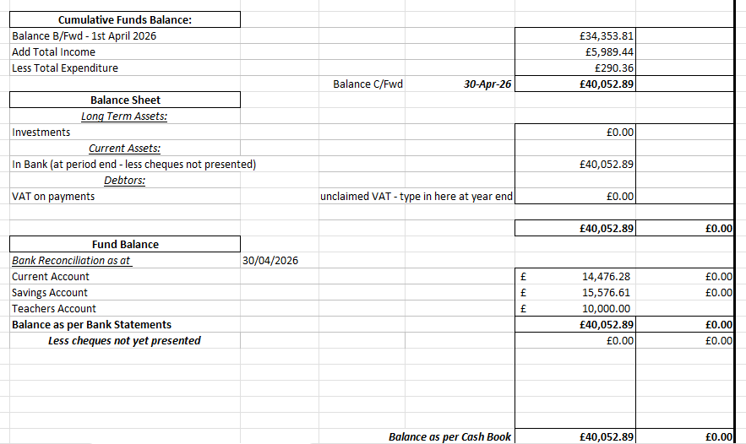
- Councillors Reports
Trees
A routine inspection has been completed with no obvious changes noted. An inspection and report from the arborist are still awaited. A date has not yet been confirmed and will require follow-up.

Highways
- Martins Lane and Hanbury Hill have been resurfaced. Wood Lane remains outstanding.
- Telegraph poles installed by Fibre Connect on Anslow Road remain positioned on the edge of the road. A follow-up email has been sent and a report reference number issued; no response has yet been received from Highways after three months.
- The replacement Wood Lane sign has not yet been installed.
- The SID situation remains on hold. Feedback is awaited regarding the use of tripods.
- Speeding on Anslow Road continues to be reported as an issue. Several incidents involving local motorcyclists have recently featured on Hanbury Watch.
- Following the fatality at Anslow crossroads on 8 August 2025, the Coroner’s Office has confirmed that the inquest will take place on Wednesday 20 May.
The law in relation to septic tanks were discussed due to a complaint that has been received. It was agreed to discuss this with the owners of the property
Damaged sign on junction of Knightsfield Road & Wood Lane was discussed, and this has now been rectified.
The bent fingerpost at the same junction was also discussed and it was agreed to report this to Staffs County Council as well as the damaged road signs to East Staffs Borough Council.
The church service to welcome the new vicar, Liz Chamberlain will be taking place on Wednesday 20th May at 7pm.
Action: It was agreed to report the bent fingerpost via the staffs report it app.
Meeting Closed: 20:21pm

Date of Next Parish Council Meeting is– Monday 14th July 2025
Parish Council Information can be found on the internet at - https;//www.hanburyparishcouncil.org.uk

Signature of the Chairman:………………………………………………..

Date:…………………………………………

